## Lab 3-01: Cloud Storage Security

### Lab Prerequisites

* Familiarity with basic Google Cloud Computing concepts and terminology.
* A Google account with an active subscription.

### Service Introduction

Google Cloud Platform (GCP) Cloud Storage offers multiple security features to ensure the confidentiality, integrity, and availability of data stored in the cloud. One of the aspects of security is access control.

Access controls in GCP Cloud Storage allow you to manage who can access your data and what actions they can perform on it. You can set up access control lists (ACLs) to control access at the bucket and object levels. You can also use Identity and Access Management (IAM) to manage access to resources in GCP.

### Case Study Social Media Platform– NetNeighborhood

Background

NetNeighborhood is a social media company that has been deployed on the GCP servers. The company provides a platform for people to connect and share information with others in their local communities. NetNeighborhood allows users to create profiles, join groups, and post updates and announcements to share with others in their community. The platform is designed to promote local businesses, events, and community resources and to facilitate communication between residents of the same neighborhood.

By leveraging GCP, NetNeighborhood can scale its platform to handle increased traffic and user demand while maintaining high levels of performance and reliability. This allows the company to focus on building new features and improving the user experience rather than worrying about managing infrastructure and server resources.

Overall, NetNeighborhood aims to create a sense of community and connection among people who live in the same area and provide a platform to share information, resources, and ideas. With GCP, the company has a flexible and scalable infrastructure that can adapt to changing user needs and support continued growth and innovation.

### Business Challenge

As a social media company, its servers are extremely prone to data stealing attempts. The users have entrusted the company with their personal information. Therefore, it would cause extreme legal and financial hurdles if the information were stolen.

One aspect of data stealing is linked with the GCP accounts as well. If an account is compromised, all the data can be stolen. Therefore, already using GCP, NetNeighbourhood is looking for a solution within the GCP to prevent potential data stealing.

### Proposed Solution

As the company is already using Cloud Storage, you have suggested the restriction of storage bucket access, i.e., only the management accounts can access it, and all the other employees should be restricted. Furthermore, you have proposed that the security operations be carried out through the command line so only the developer can perform operations on it.

Lab Diagram

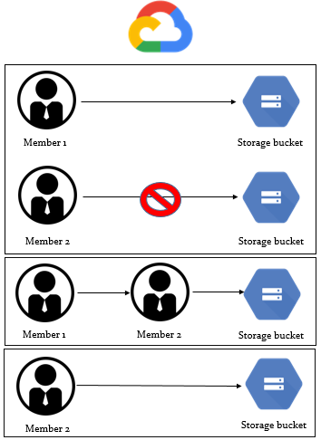

Figure 3-02: Lab diagram

Implementation Steps

Solution

1. Log in to the GCP console on both accounts: the first account (Account A), which assigns permission to the second account, and the second account (Account B), which currently has no access to the resources.

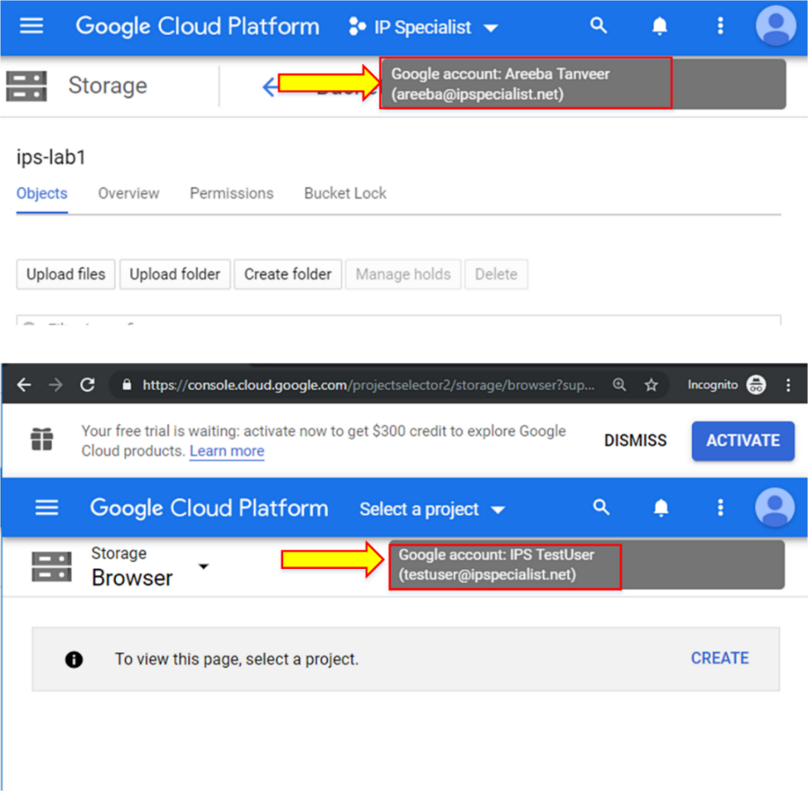

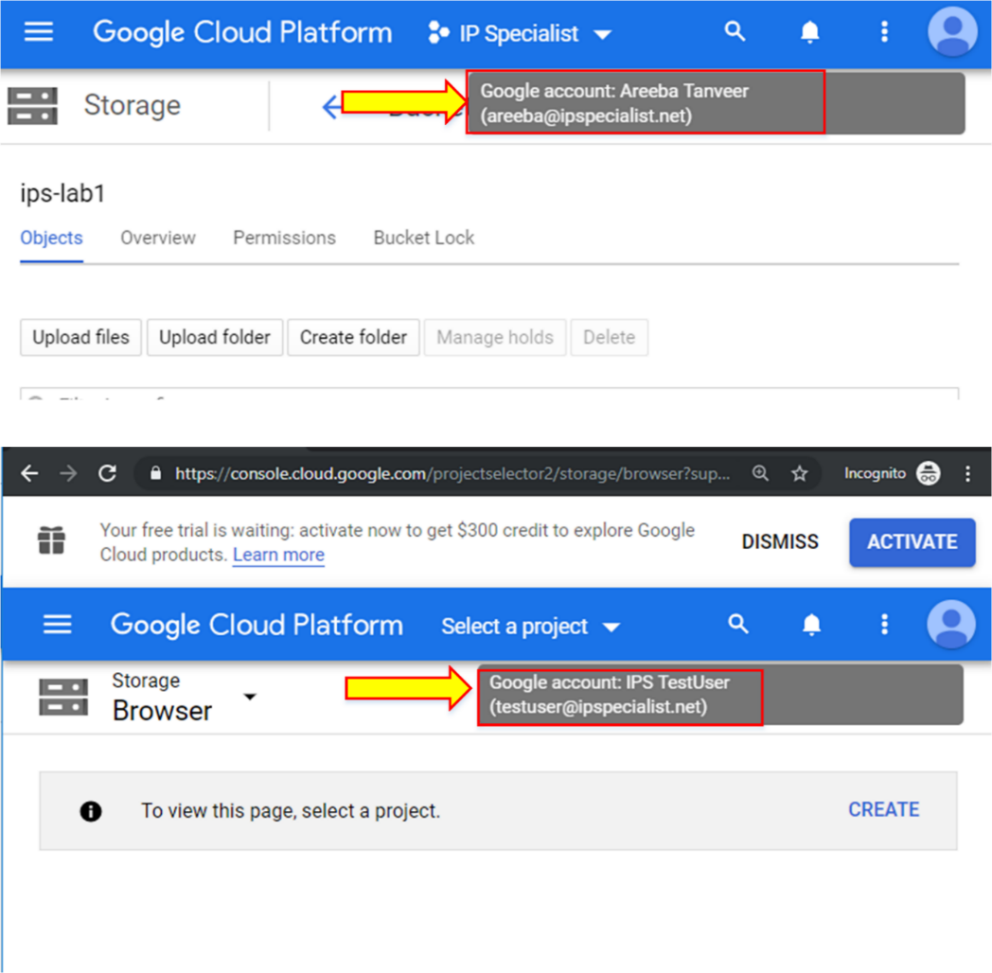

1. First, assign an IAM role to Account A for a bucket in the project, but not to the entire project, by going into “SHOW INFO PANEL”, then “Add members”, and add the account to which you want to assign permissions with an appropriate role.

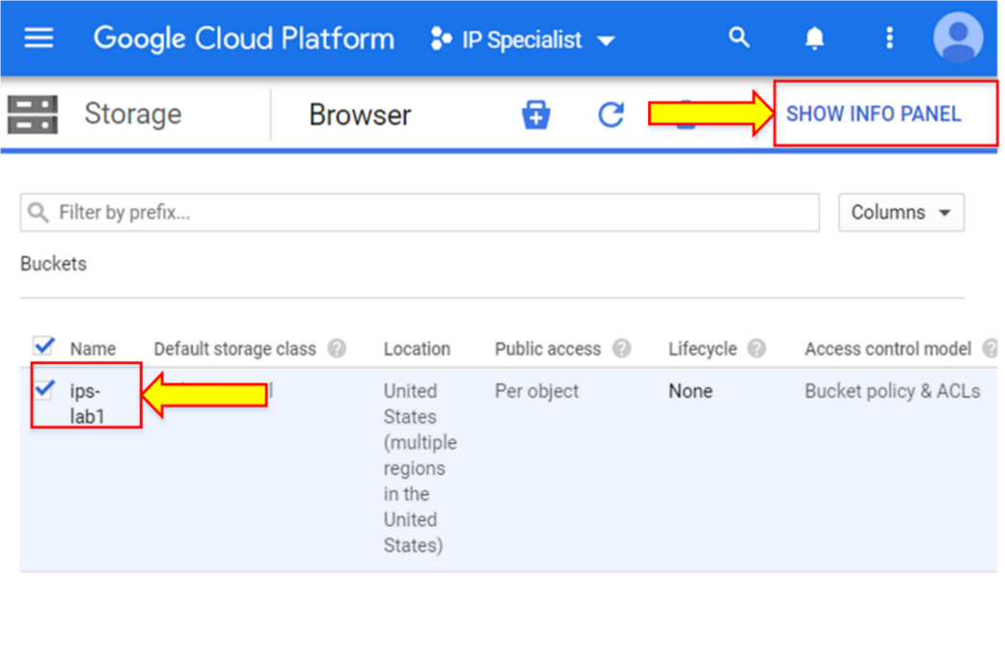

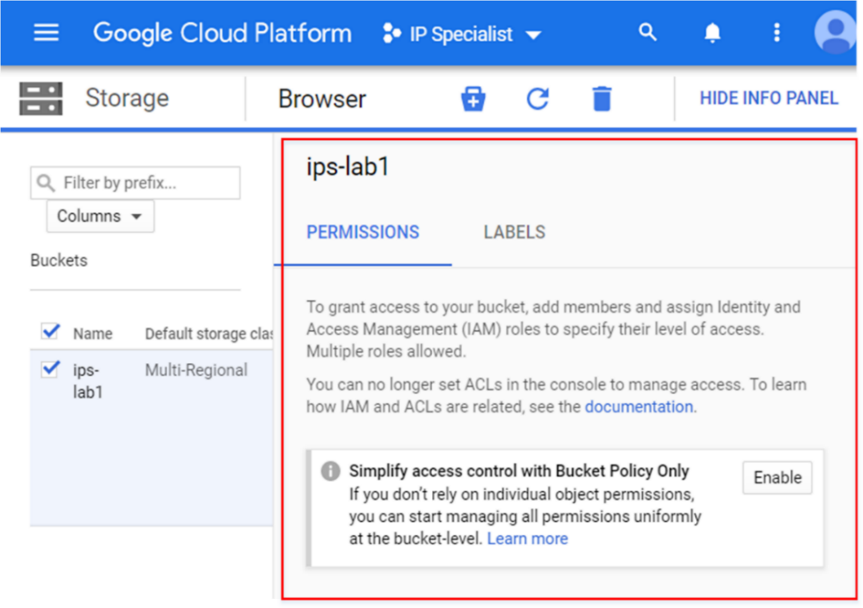

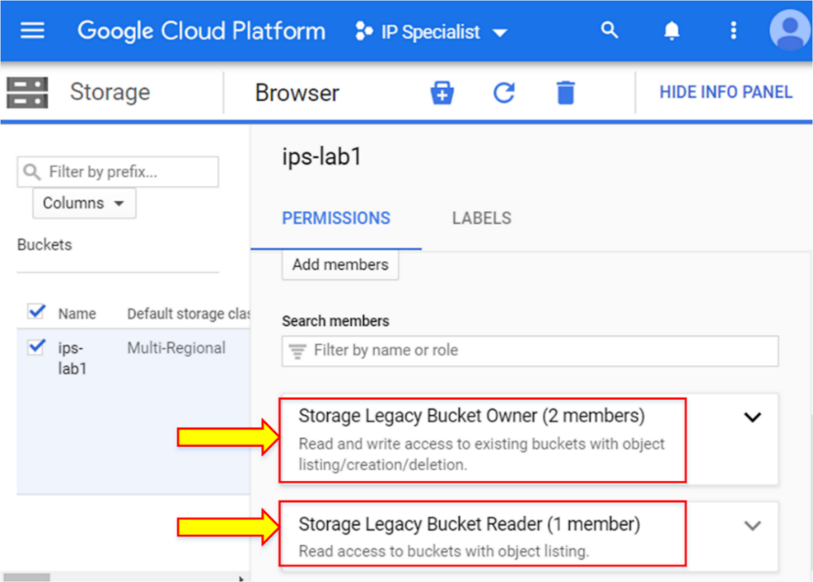

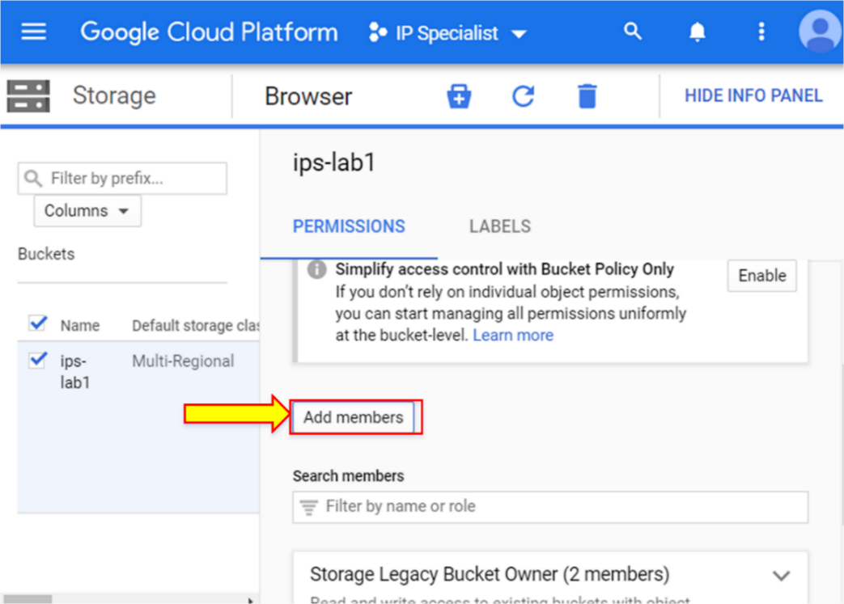

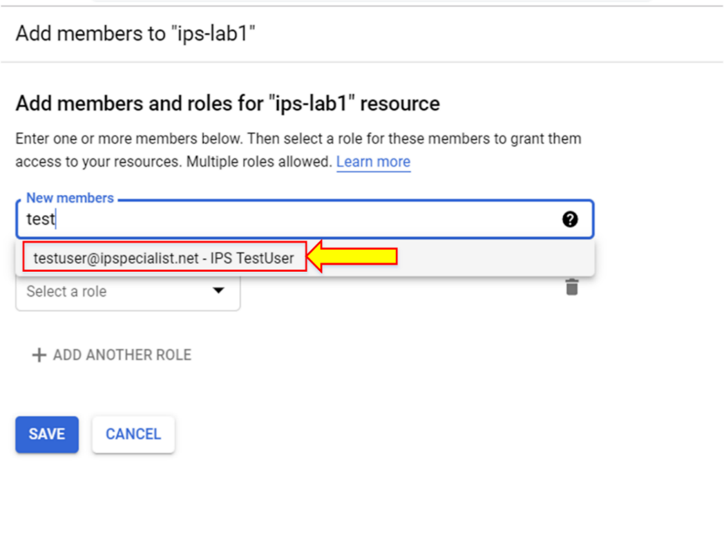

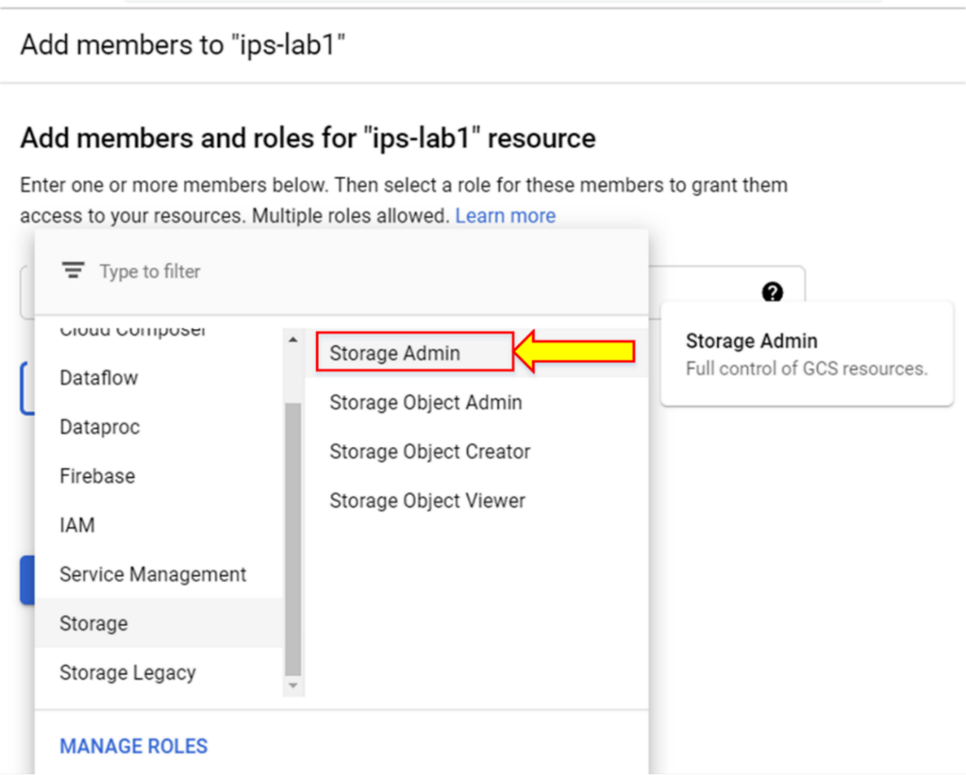

1. Click “SAVE”. Go to “SHOW INFO PANEL” again, and in “Storage Admin”, you will see that an account has been assigned with a storage admin permission.

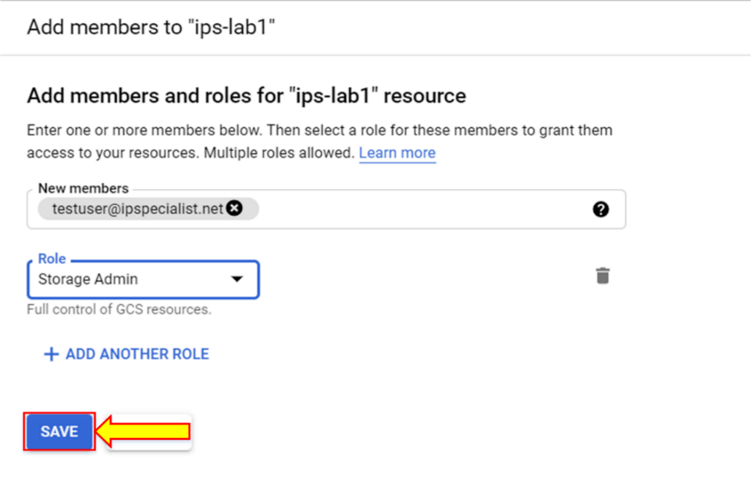

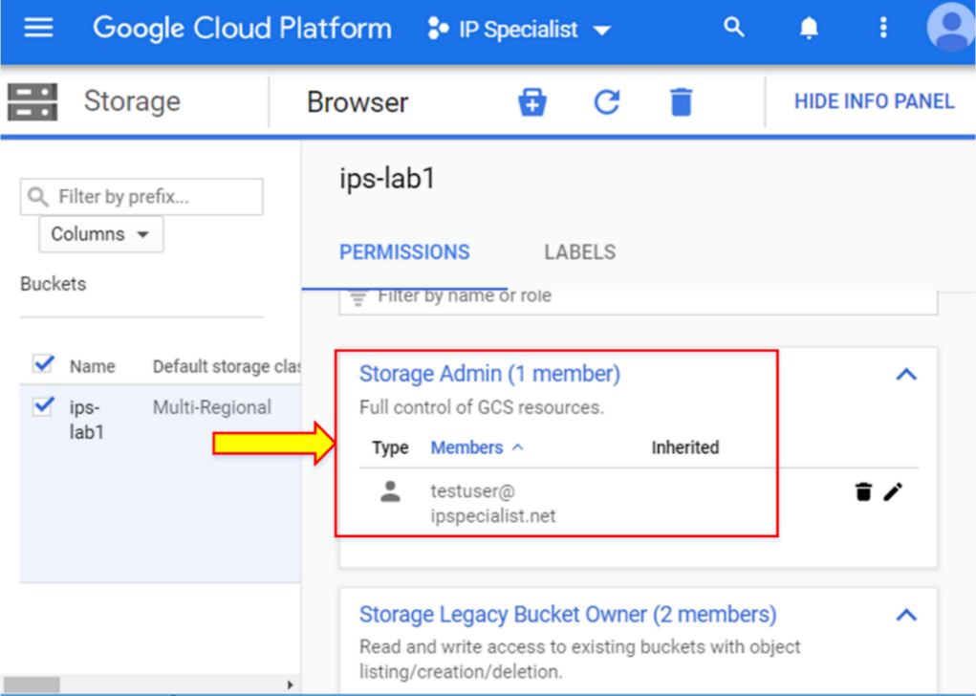

1. Now go to the “Overview” tab and copy the link URL. Go to the other account console and paste that link. That account will then be able to go into the bucket directly via this link.

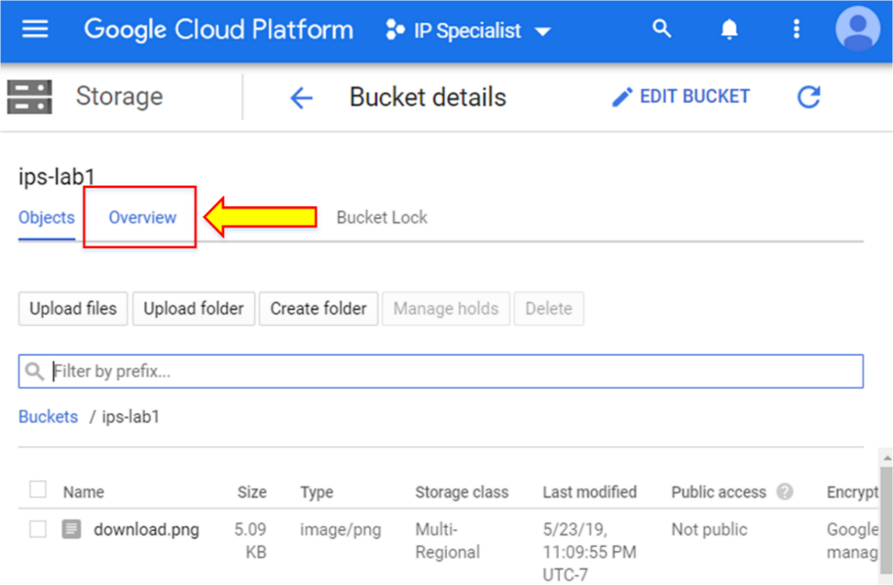

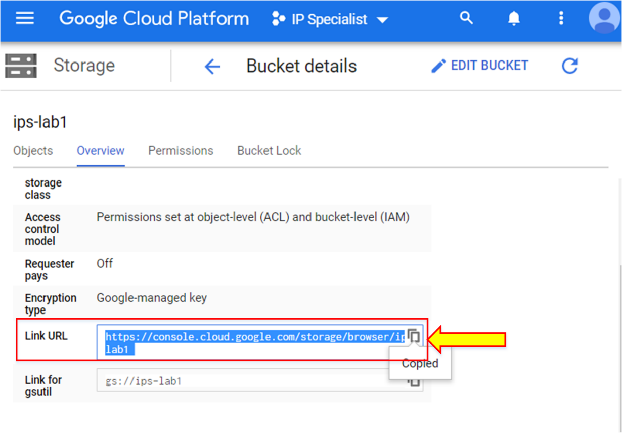

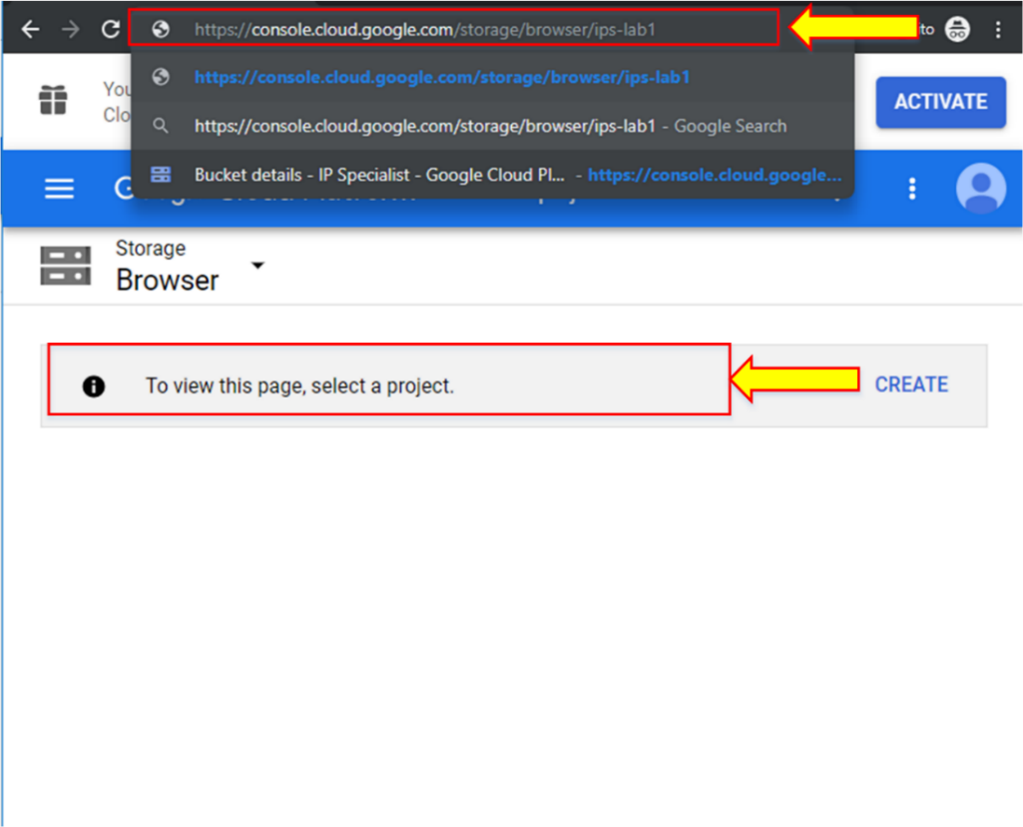

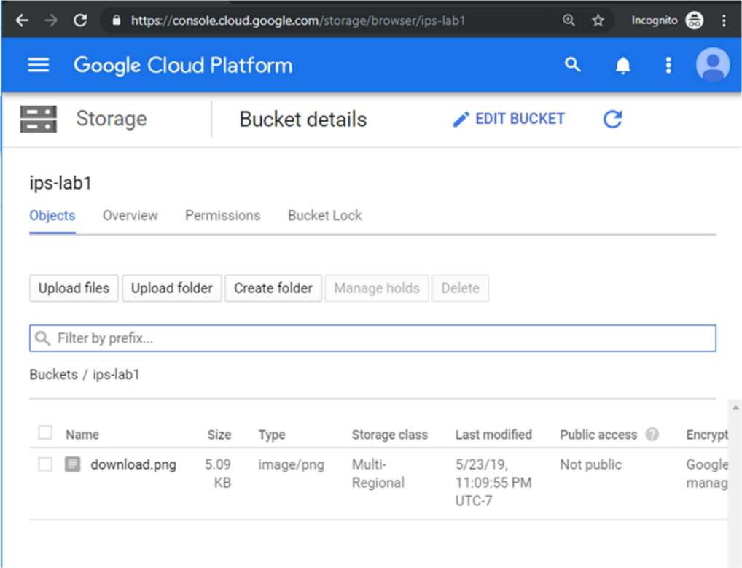

1. Now, go to “SHOW INFO PANEL” and delete that role. We will assign a role to that account with gsutil.
2. In Cloud Shell, type the command “gsutil iam ch user:<user_emailid>:<role1>,<role2> gs://<bucketname>”.

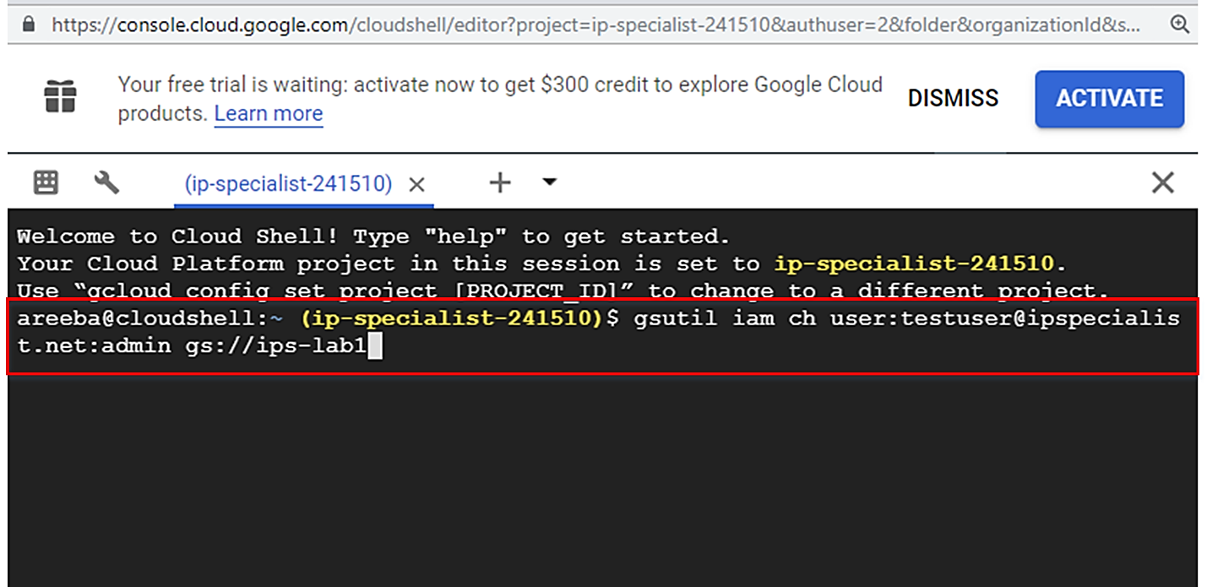

1. Check the console as well by going into the info panel and in “PERMISSIONS”, you can view the role that you assigned to the user in Account B.

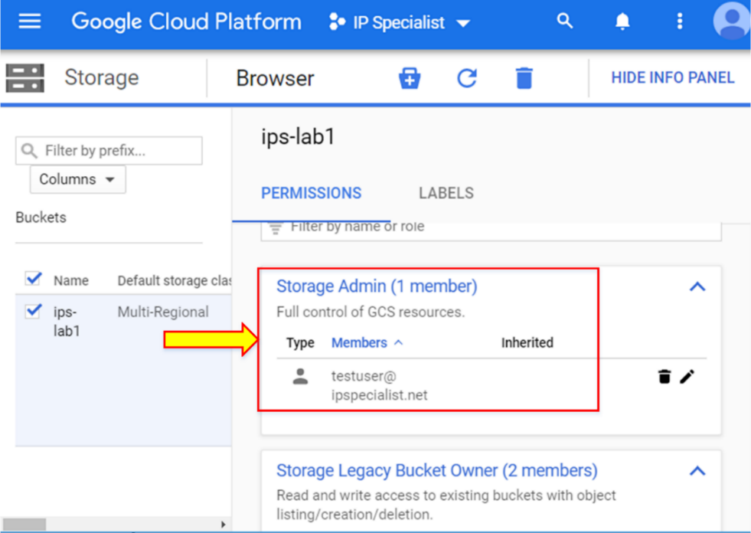

1. To delete the iam role, type the command “gsutil iam ch –d user:<user_emailid>:<role1>,<role2> gs://<bucketname>”. To delete all roles, type the command “gsutil iam ch –d user:<user_emailid> gs://<bucketname>”.

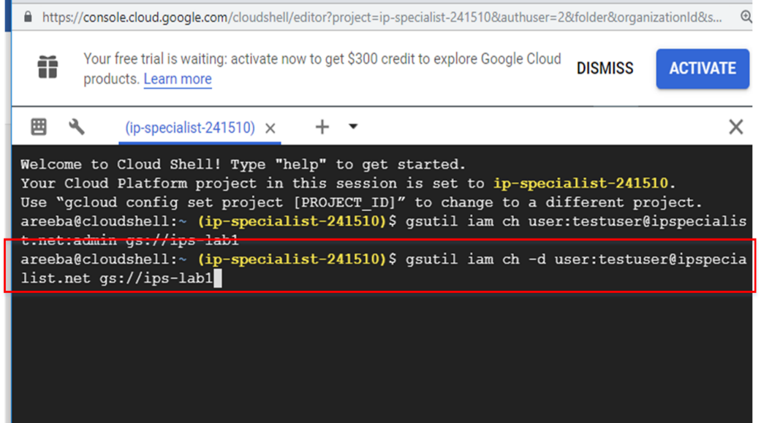

In console, you can also see the role has been deleted.

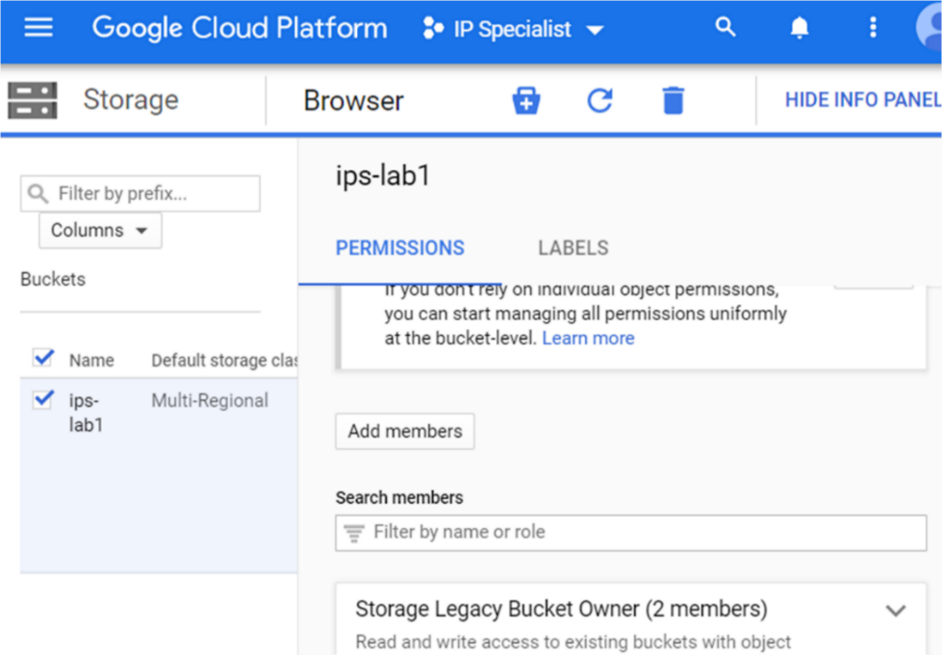

ACL permissions are independent of IAM. To apply ACL to an individual object, you need to use Cloud Shell, while you can only apply ACL to bucket level via console.

1. Go to GCP console and click on “SHOW INFO PANEL”. Then click the “Add members” button and type “allUsers” with Legacy Object Reader access named as “Storage Legacy Object Reader”. By doing this, the bucket becomes publically available.

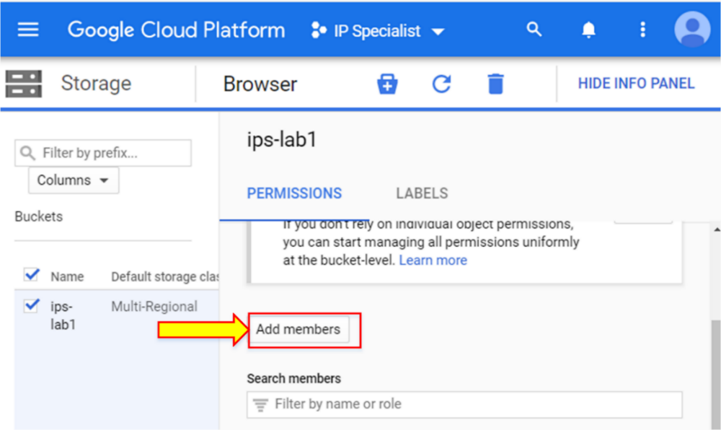

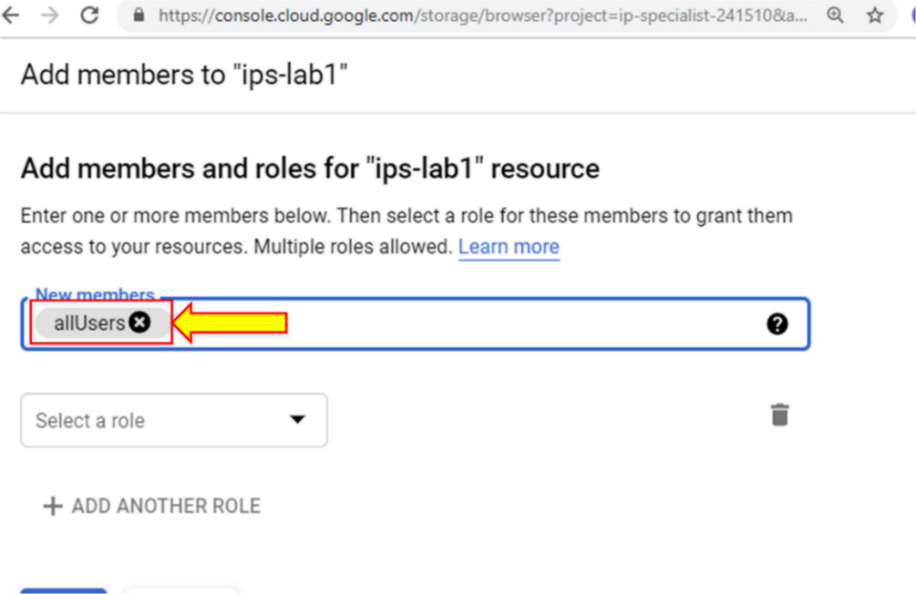

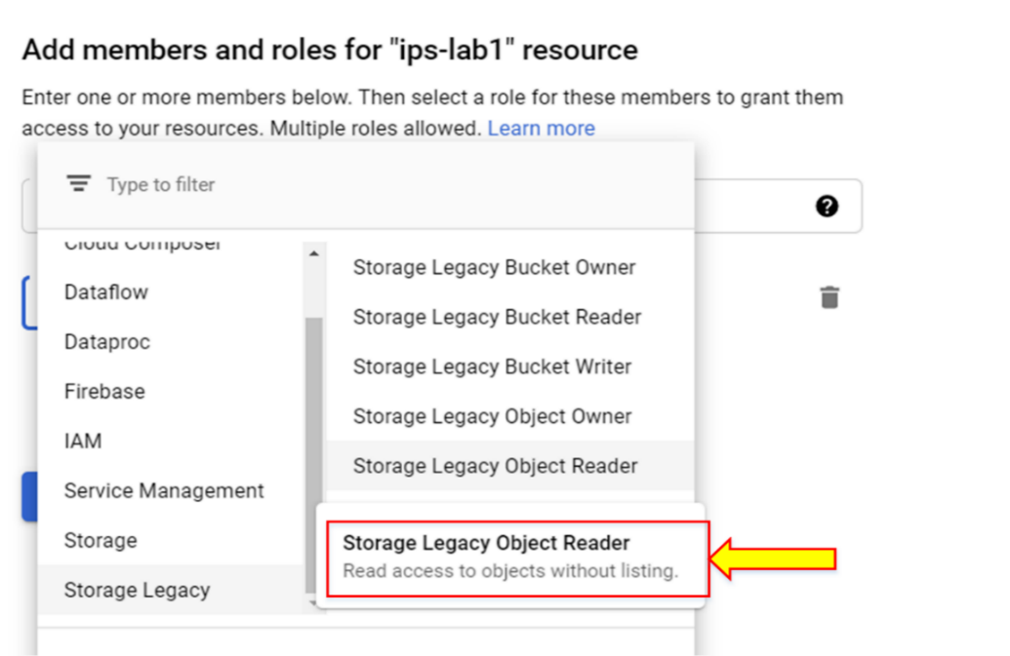

1. Click “SAVE”. Now you see that the resource has become public.

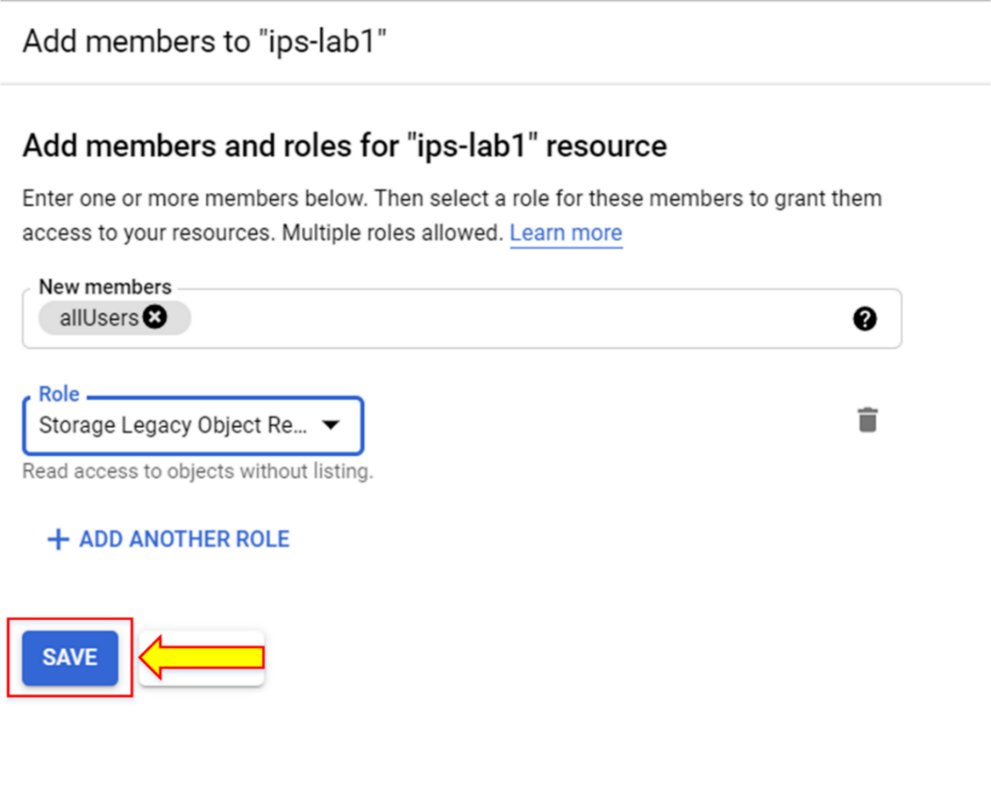

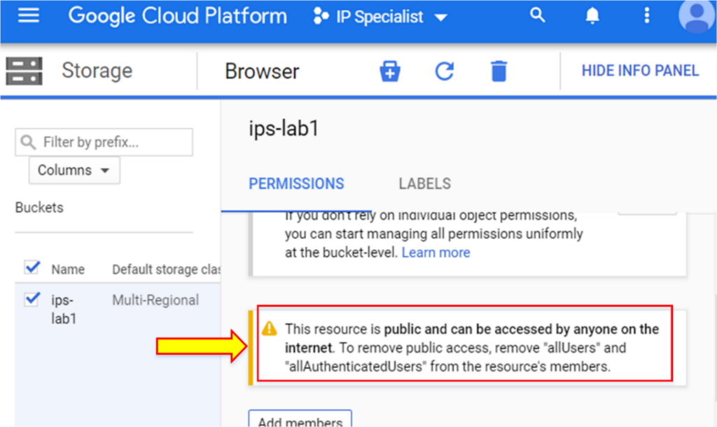

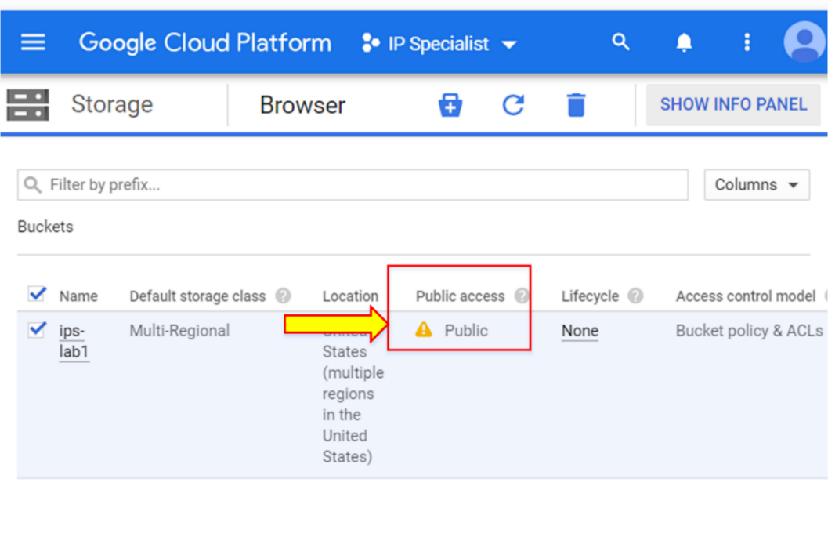

1. Now, click on any object’s public link, which will open up in another browser. You will see that the object is publicly available.

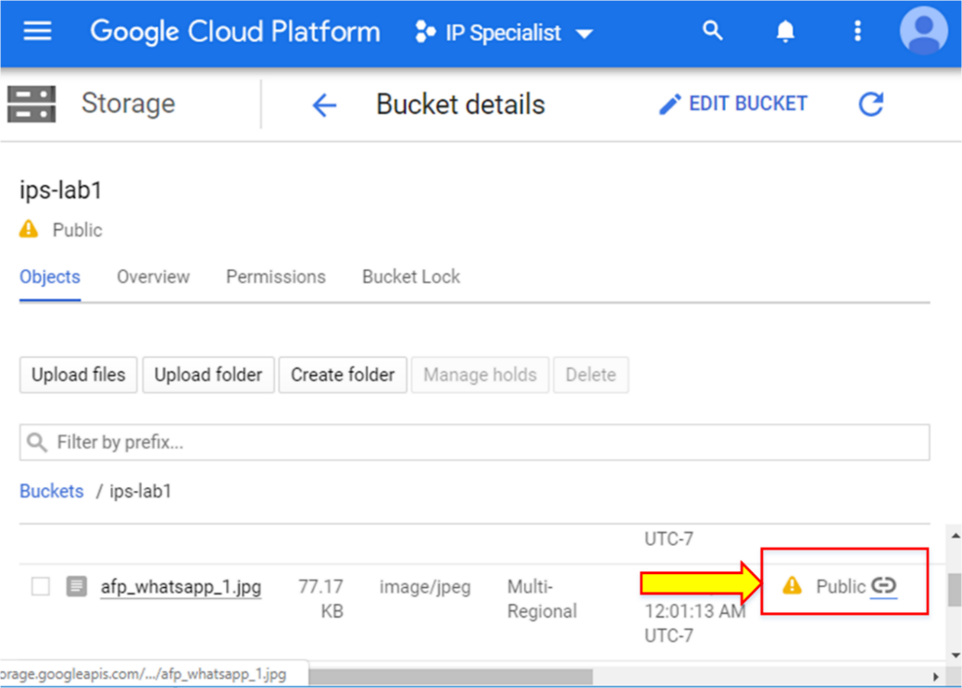

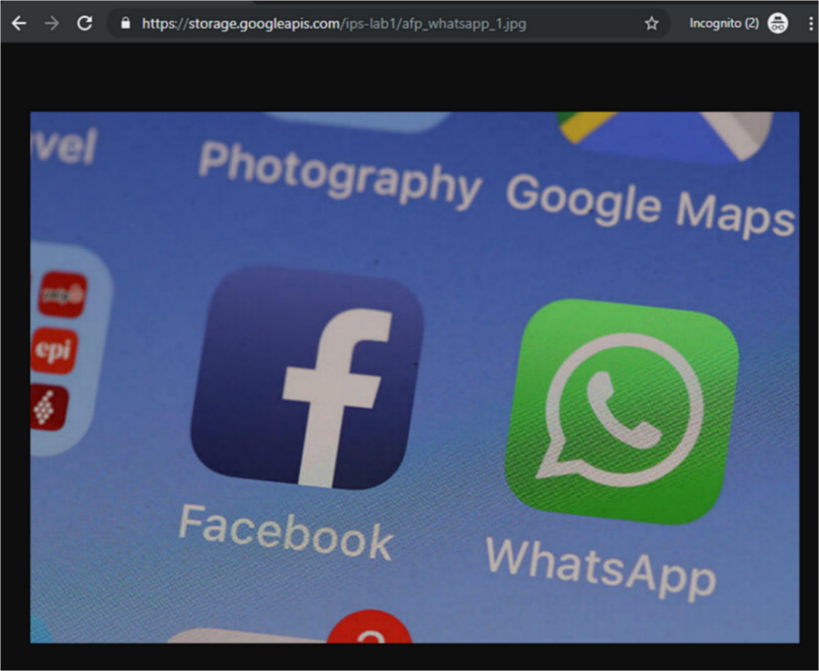

1. To remove this public permission, go to “Permission” and click the delete icon to remove public access from the bucket. A pop-up window will appear; click “REMOVE”.

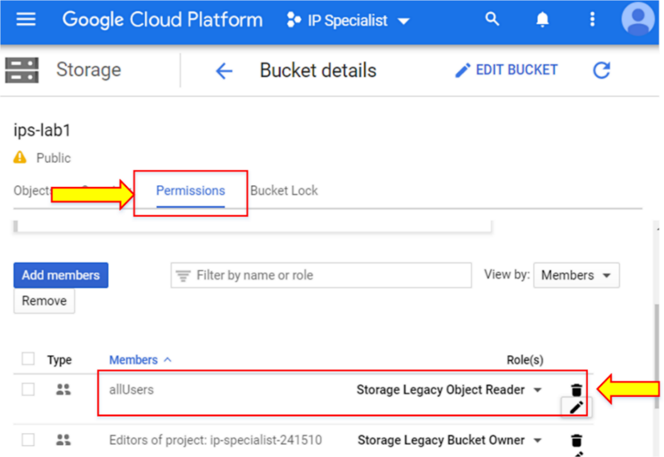

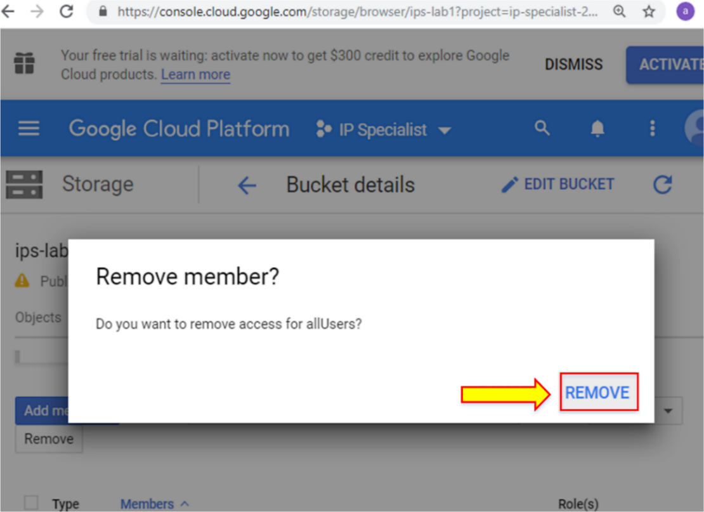

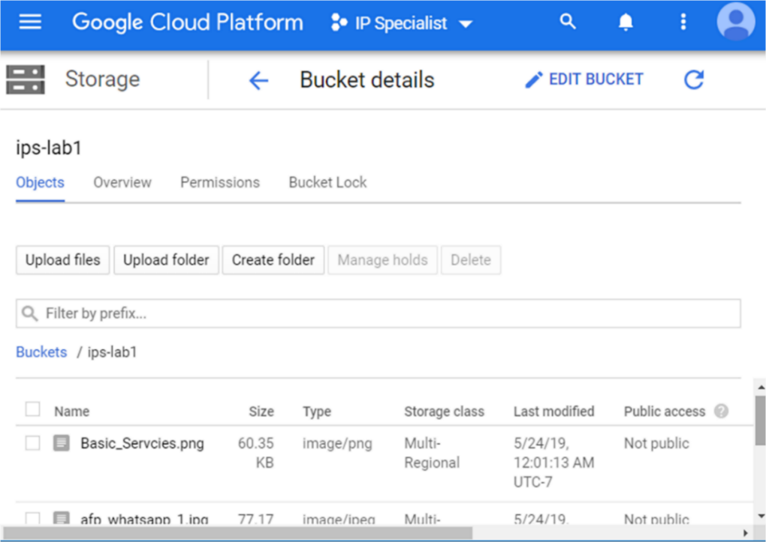

1. Go to Cloud Shell to apply ACL on a single object. Type the command “gsutil acl ch –u <user email>:<O/R/W> gs://<bucketname>/<objectname>”. Here “O” is for owner access, “R” is for reader access, and “Q” is for writer access.

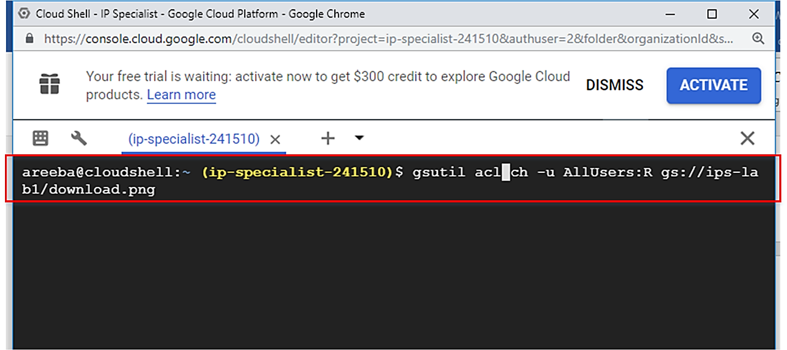

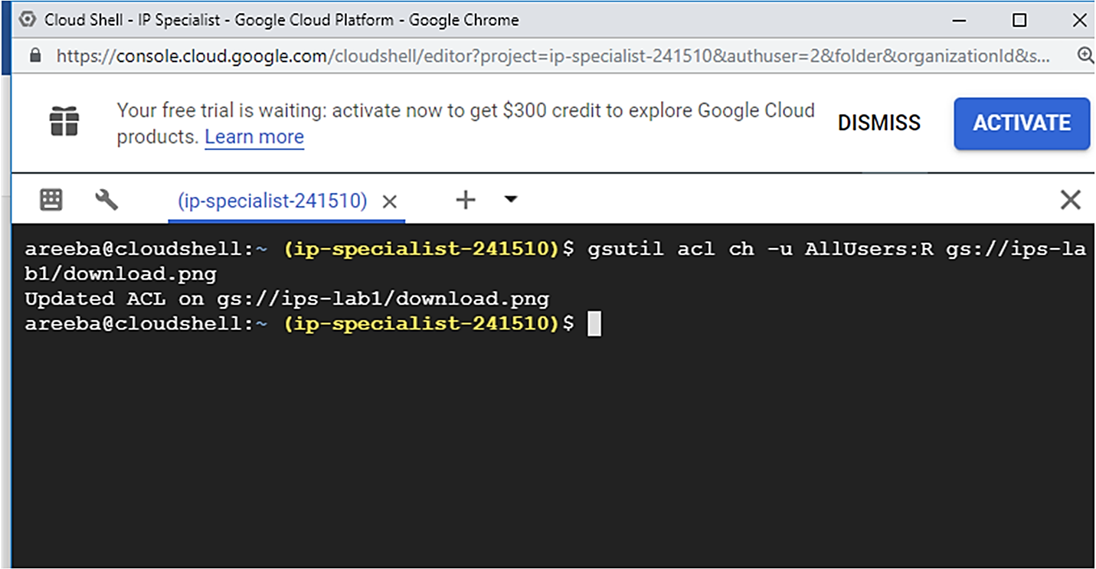

After assigning access, you can check any access by going into GCP console. Here, we assigned a public access of a single object to all users.

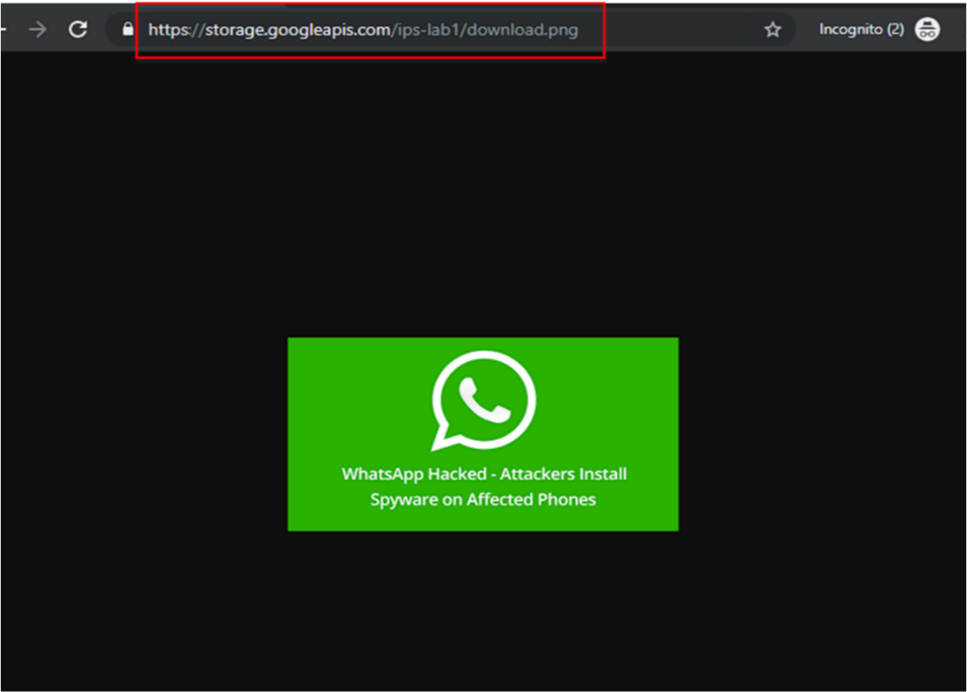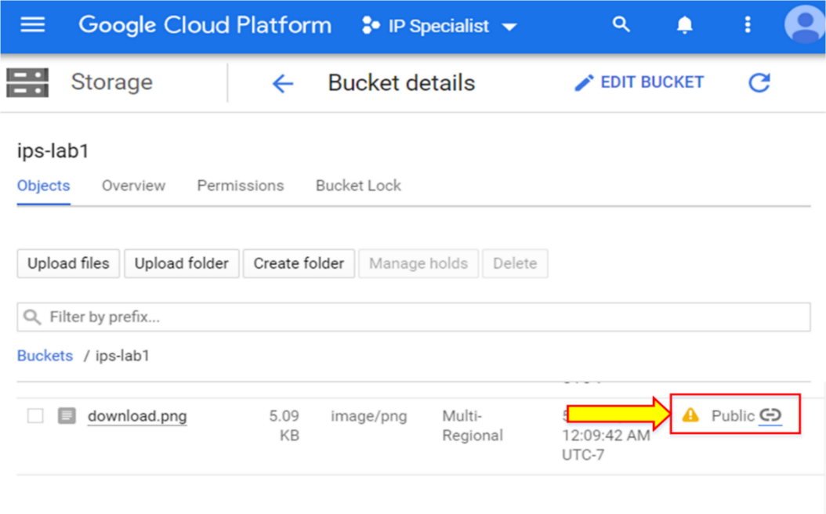

1. To remove this public access, type the command “ gsutil acl ch –d <user email> gs://<bucketname>”.

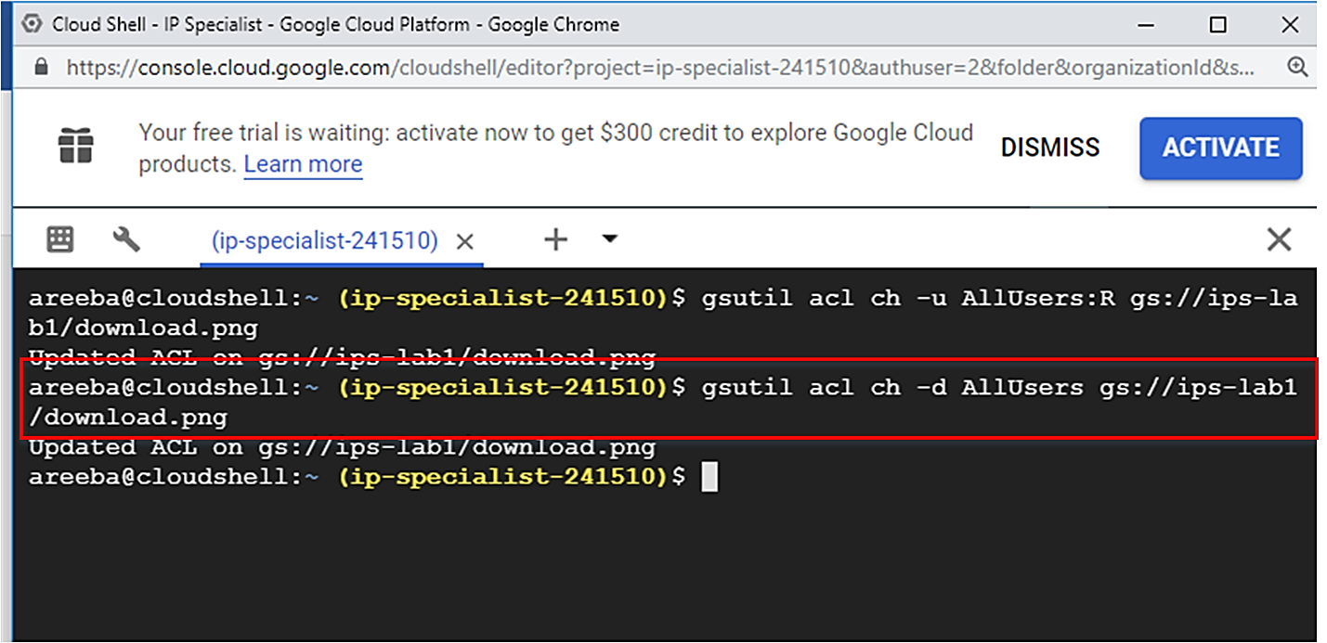

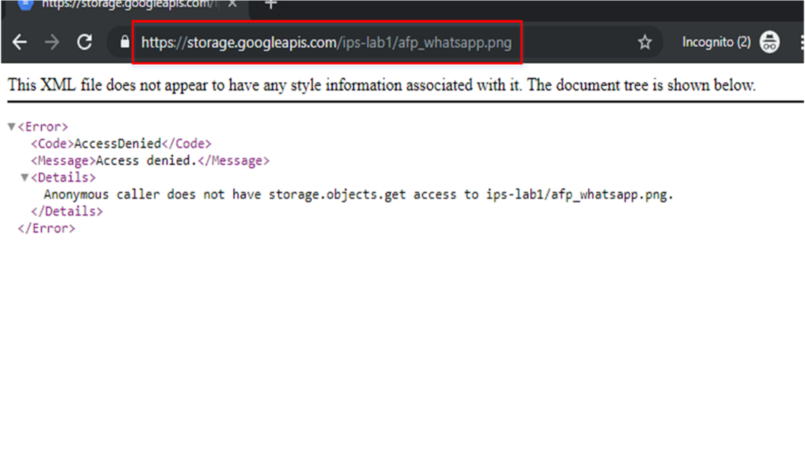

By going into the GCP console, you can also verify if the object’s public access has been removed.

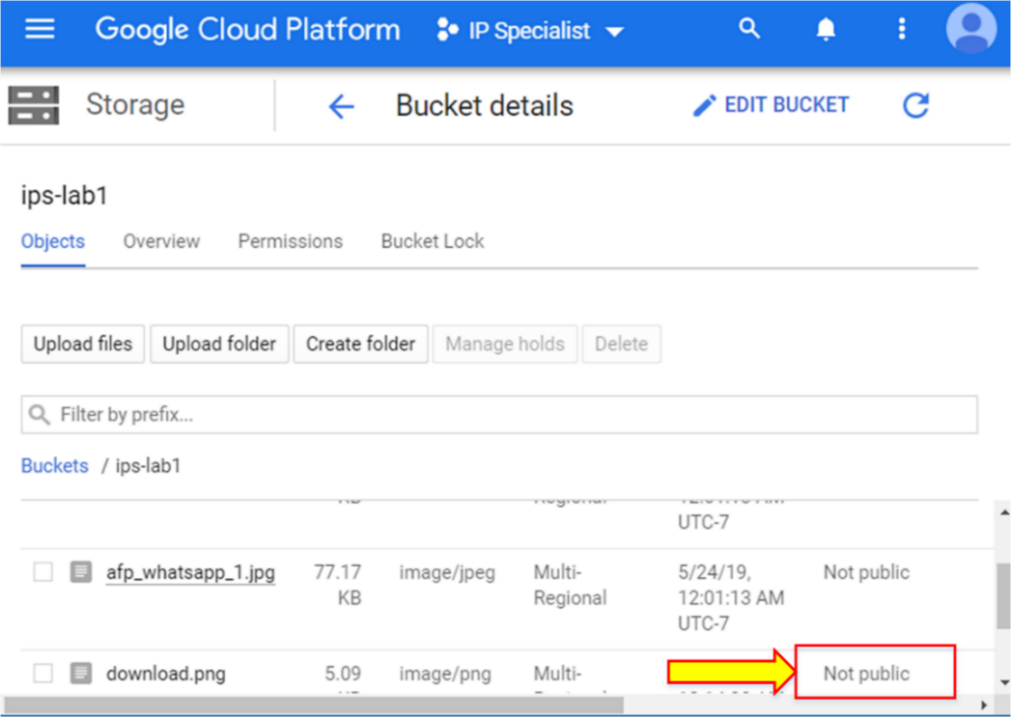

To create a signed URL that provides temporary and timely access to resources, you need to create a service account with the key that is used to generate the signed URL.

1. Go to “Service accounts” from IAM and Admin. Click “CREATE SERVICE ACCOUNT”.

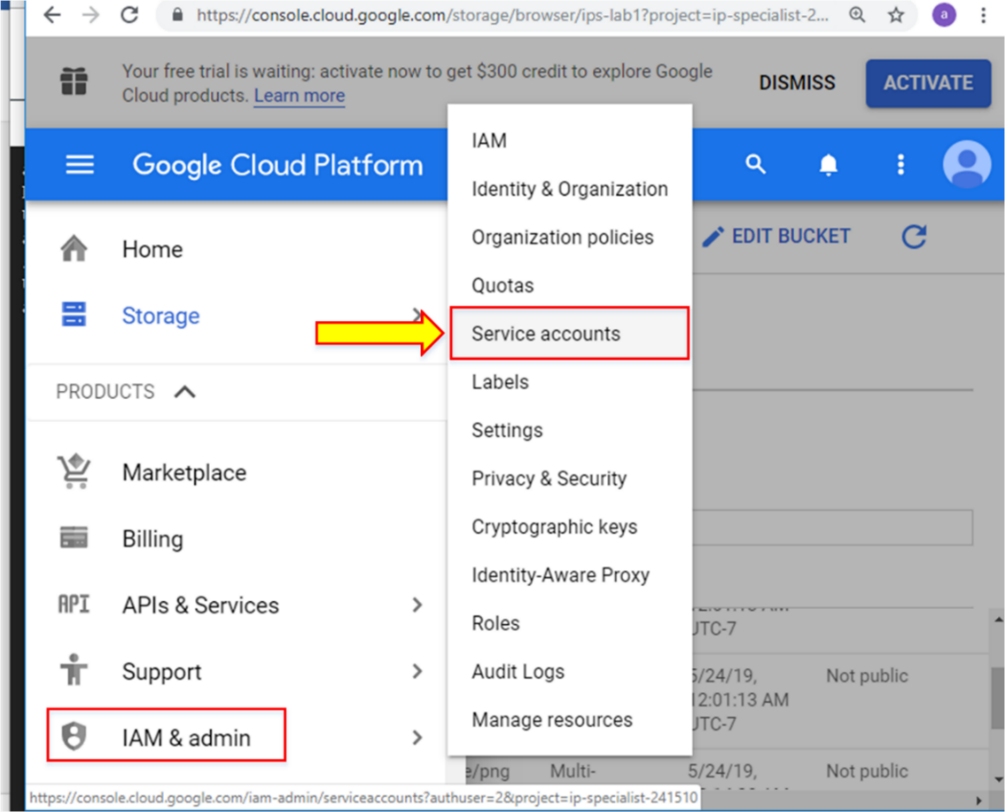

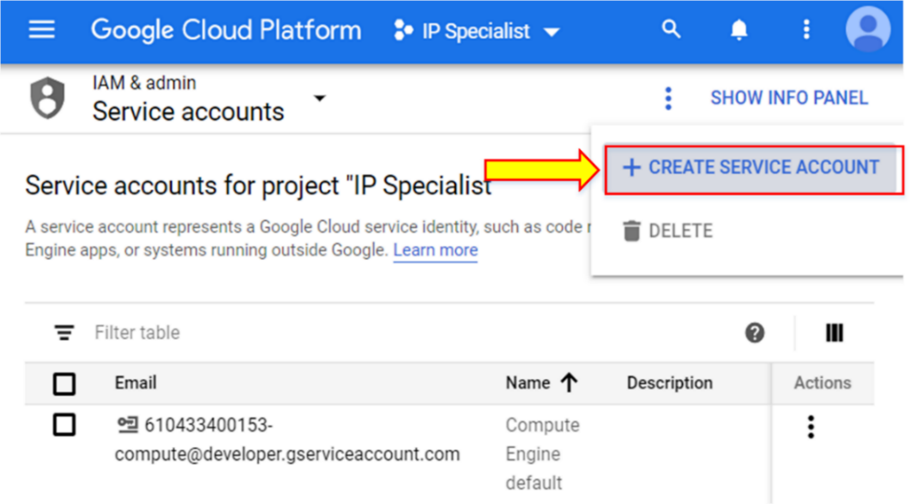

1. Enter the name of the service account and click “CREATE”.

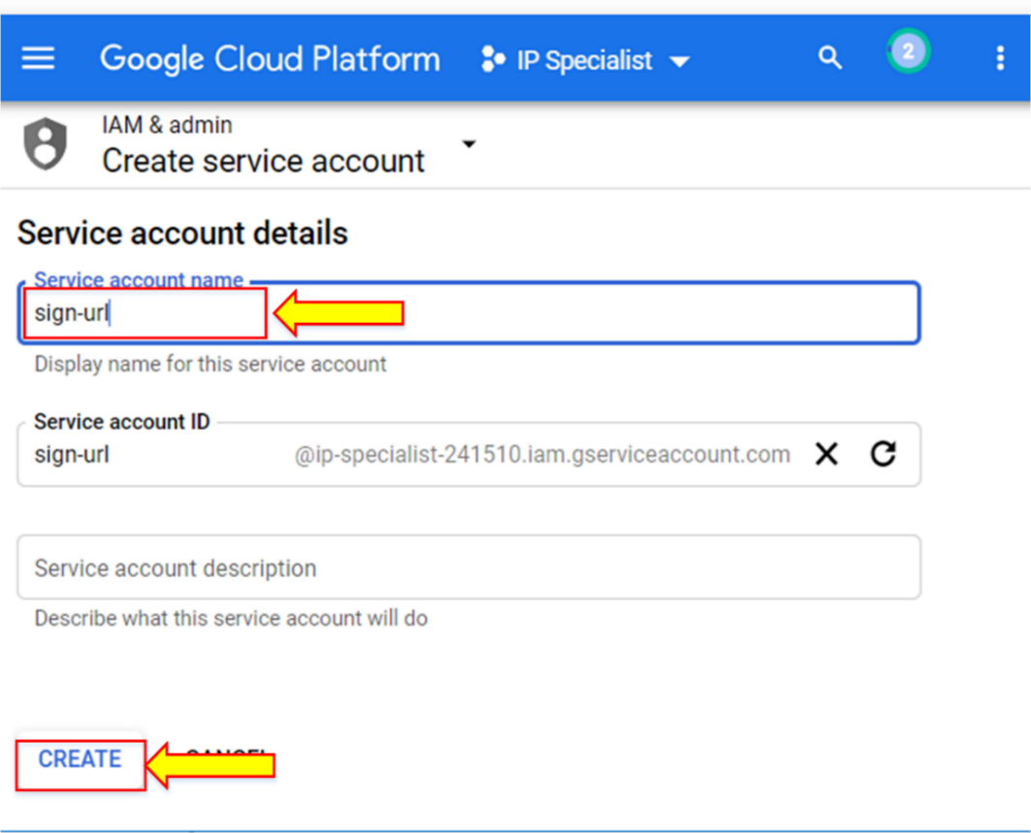

1. Now, assign the Cloud Storage Admin role to the service account and click “CONTINUE”.

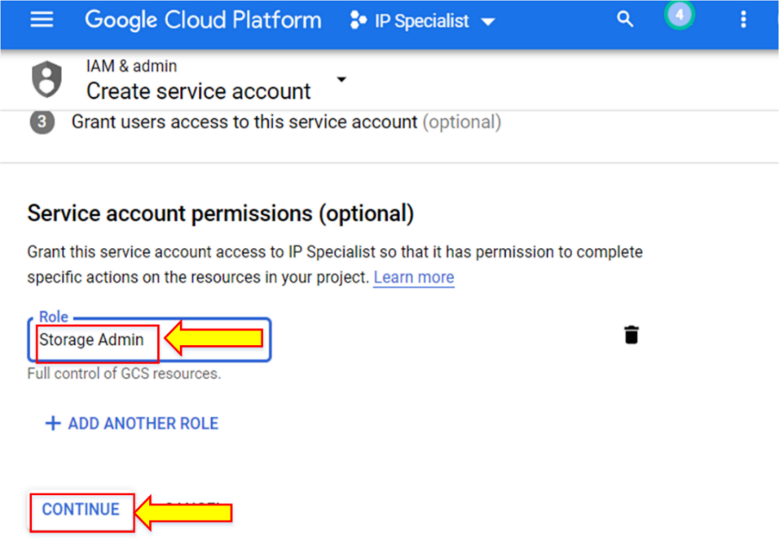

1. Now in “Create Key”, click on “CREATE KEY”.

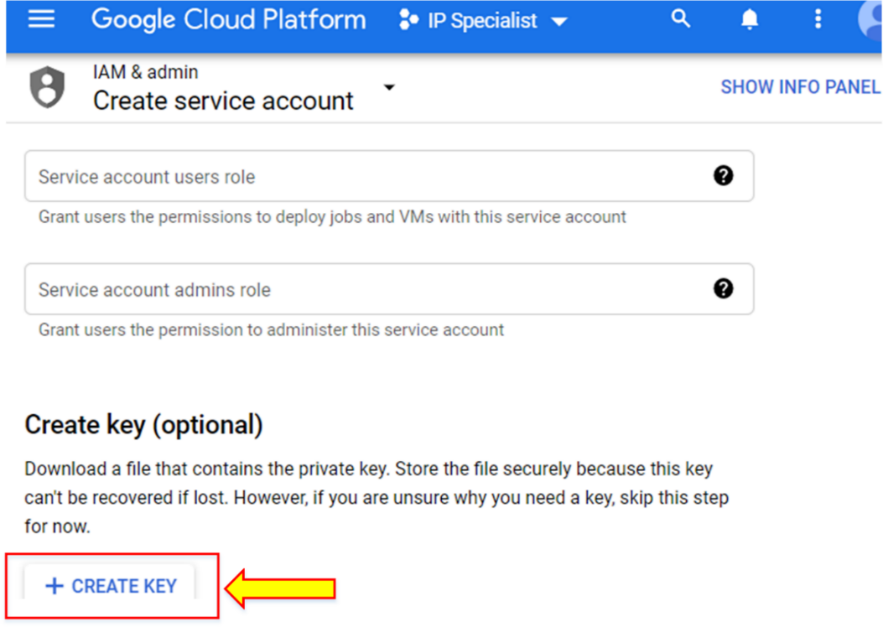

1. Then select the key format and click on “CREATE”. This will automatically download a key file to the local system.

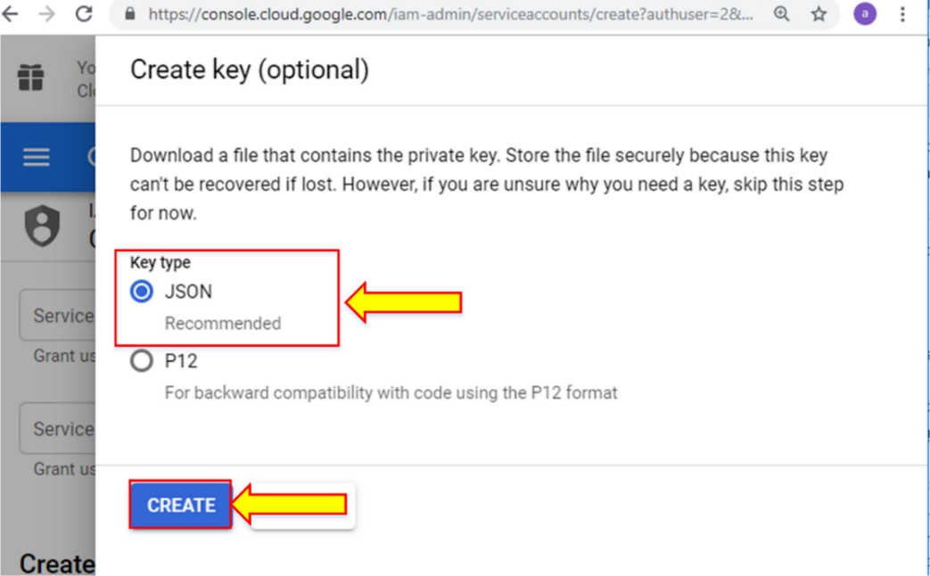

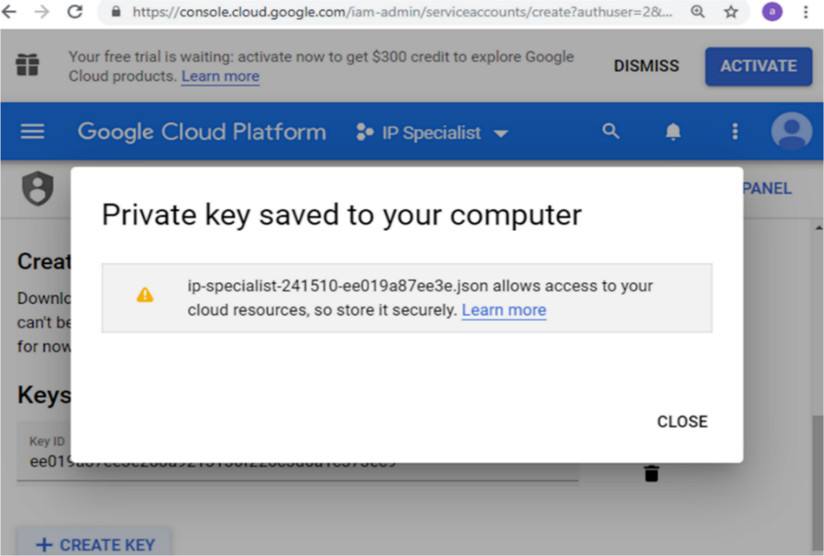

1. Put this file in the directory where Cloud SDK exists. Provide a name that you can easily remember for later use.

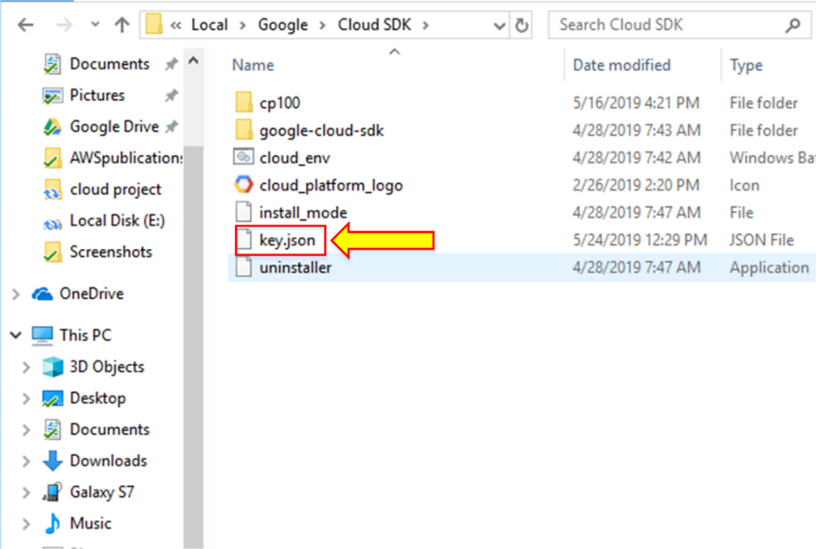

1. For the “signurl” command, you need the Python package installed in CLI; run the “signurl” command in Cloud SDK. Go to the project and type the command “gsutil signurl -d 10m <filename.json> gs://<bucektname>/<object>”.

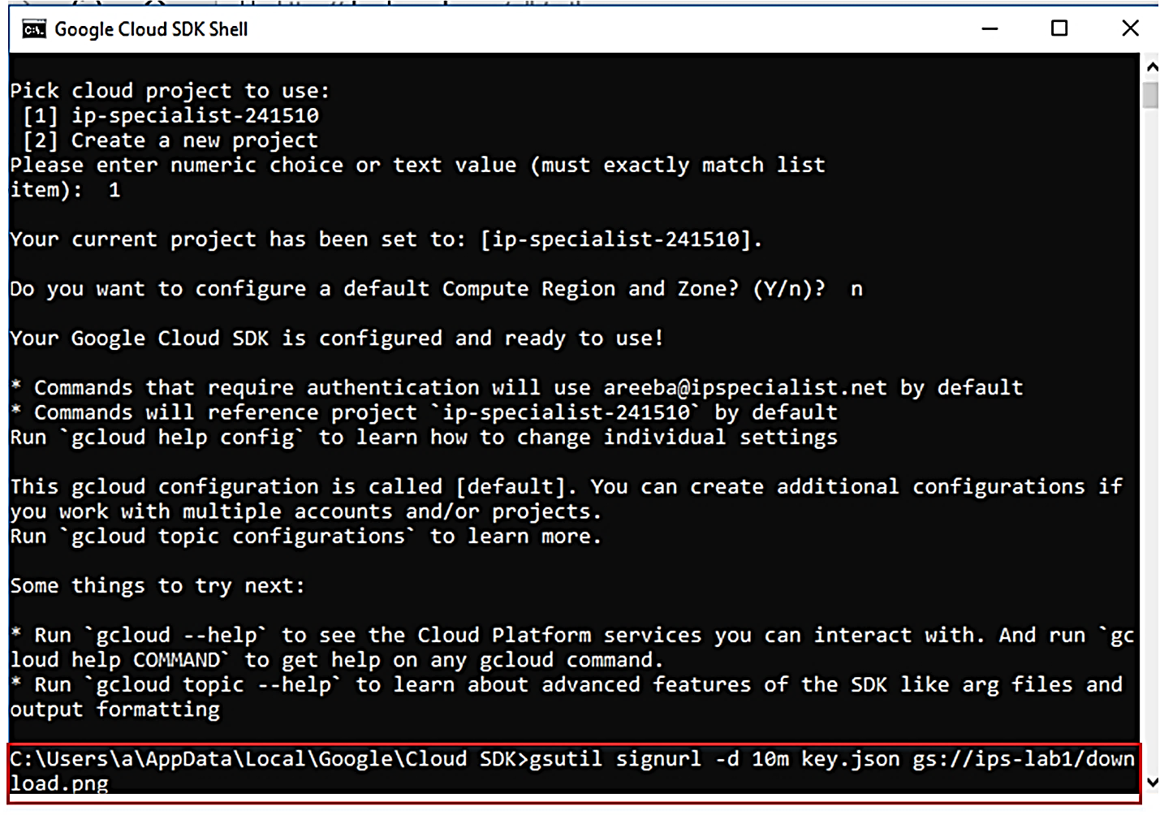

1. Now, you will get a URL that is valid for 10 minutes, as mentioned in the command. Copy the URL to your browser in order to view your object.

